|  |
| --- |
| Close-up image showing the leaf-sides of two oversized books side-by-side on a bookshelf, with additional books in soft focus background |
| Database Development 281  Assignment 3 |
| |  |  |  | | --- | --- | --- | | Sibahle Mayekiso | 2/22/21 | DBD281 | |

Table of Contents

Question 1 2

While Loop in SQL 2

For Loop in SQL 2

IF…ELSE Statements in SQL 2

CASE Statements in SQL 2

Question 2 3

Declaration of variables 3

Creating stored procedures 3

Utilizing built-in functions 4

References 5

# Question 1

### While Loop in SQL

A WHILE loop checks whether its condition has been met (checks if it is true) before its contents is executed. The loop can only terminate if the condition is said to be FALSE, otherwise the loop will execute indefinitely.

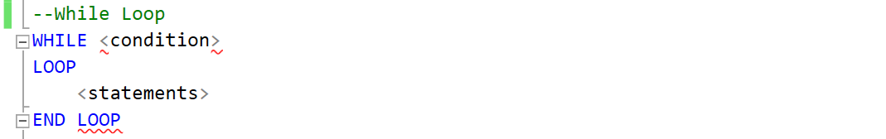

### For Loop in SQL

Numeric FOR loops specify start and end integer values where each value is iterated through, from start to end, before the loop is terminated/exited. Cursor FOR loops follow the same structure, however one explicitly provides a cursor or SELECT statement which fall in place of upper/lower bound values.

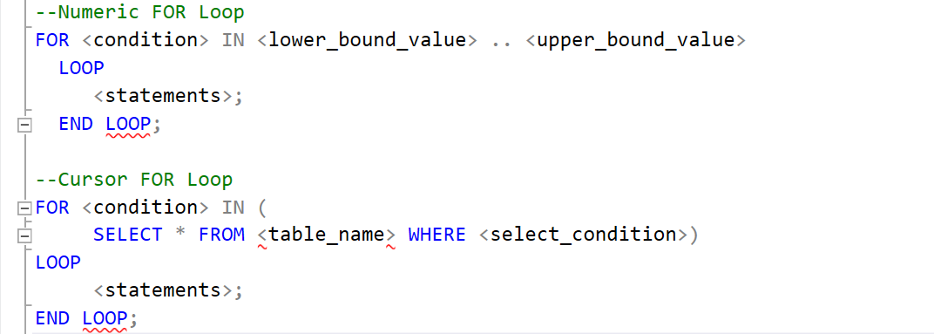

### IF…ELSE Statements in SQL

An IF statement is one of the fundamental concepts regarding conditional branching logic. An IF...ELSE statement uses either/or logic where, based on whether a condition is met, code will be executed between the THEN and ELSE keywords or code between the ELSE and the END IF keywords will be executed.

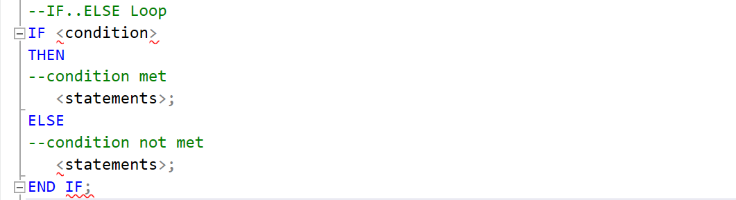

### CASE Statements in SQL

CASE statements are used in scenarios where redundant IF THEN ELSE statements are being made which clutter the code. By implementing CASE, the code becomes easier to read and understand. CASE statements come in two forms: Simple CASE statements and Searched CASE statements. Simple CASE Statements decides which sequence of statements to execute based on an expression which returns one of those values. A Searched CASE statement executes the first TRUE condition that is associated to a sequence of statements.

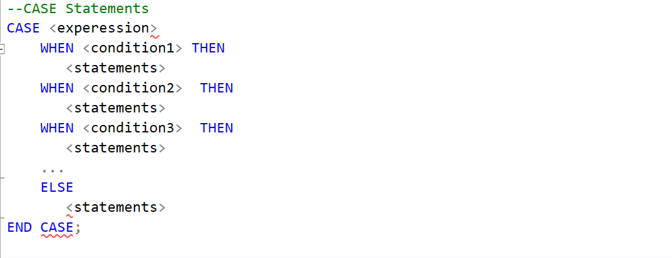

(Feuerstein, 2011)

# Question 2

### Declaration of variables

In Oracle, one does not have to add an “@” sign in front of the variable’s name but requires a semi-colon (“;”) to separate multiple variable declarations. In SQL Server, an “@” sign needs to be added before the variable’s name and requires a comma (“,”) to separate multiple variable declarations. Both Relational Database Management Systems (RDBMS) make use of the DECLARE keyword.

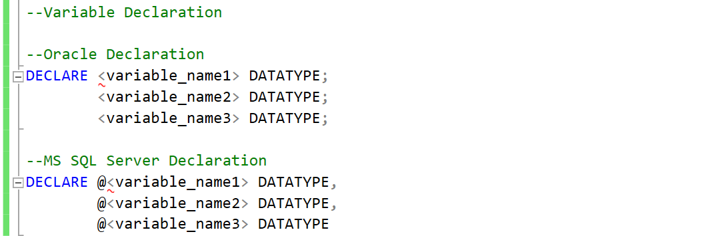

(SQL Server vs. Oracle, 2013)

### Creating stored procedures

In MS SQL Server, a stored procedure is developed using Transact-SQL where input parameters can be accepted which will then be able to return multiple values of output parameters. However, stored procedures form the basis of PL/SQL in Oracle Database. Stored procedures in Oracle follow a block structure that is made of individual declarative, executable, and exception-handling components.

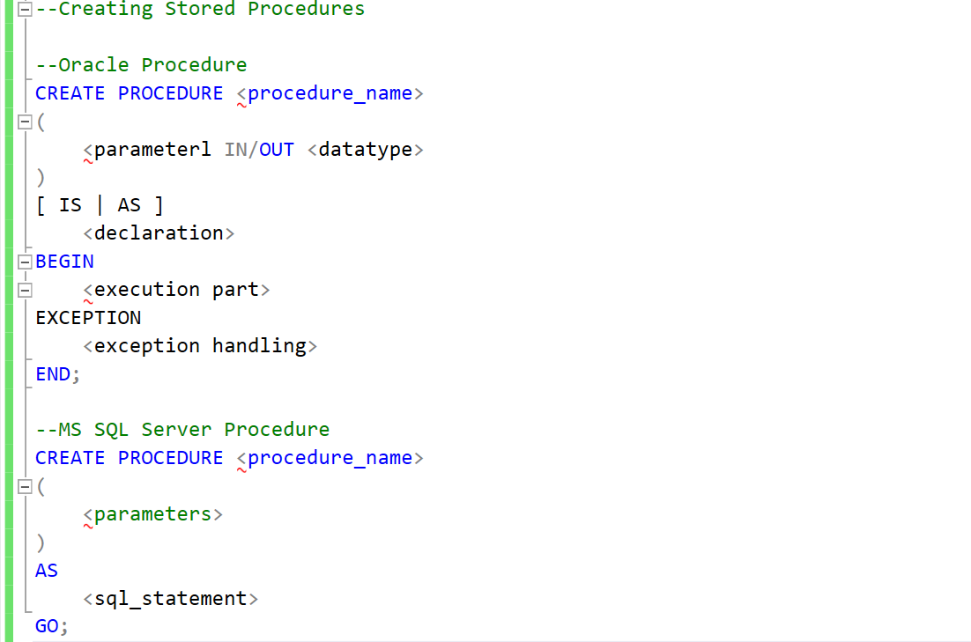

(Bhadwal, 2020)

### Utilizing built-in functions

Both MS SQL Server and Oracle offer the same built-in functions; for example, ABS, ROUND, AVG, COUNT, SUM, etc. However, there are some functions that differ slightly in how they are named and/or how they represented. The following table demonstrates a few of these slight differences:

|  |  |  |
| --- | --- | --- |
| **Description** | **Oracle DB** | **MS SQL Server** |
| Smallest integer ≥ n | CEIL | CEILING |
| Modulus | MOD | % |
| String concatenation | CONCAT (*string1*, *string2*) | *string1* + *string2* |
| Get part of a string | SUBSTR | SUBSTRING |

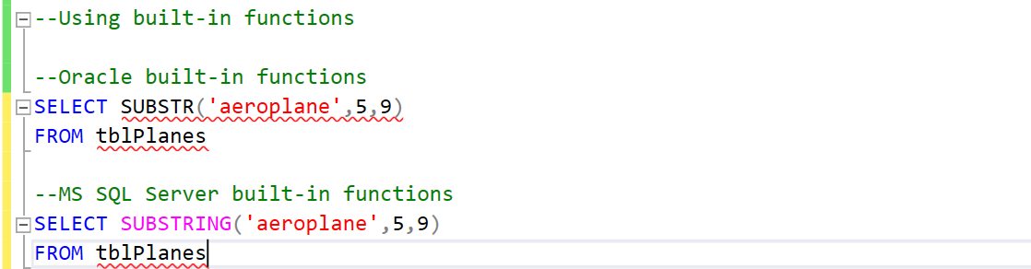

(Bristle Software, Inc, 2020)

# References

Bhadwal, A. (2020, November 02). *What You Need to Know About Stored Procedures*. Retrieved from hackr.io: https://hackr.io/blog/stored-procedures

Bristle Software, Inc. (2020). *Bristle Software SQL Tips* . Retrieved from Bristle.com: http://www.bristle.com/Tips/SQL.htm#Differences%20Between%20Oracle%20and%20MS%20SQL%20Server

Feuerstein, S. (2011, July). *Controlling the Flow of Execution*. Retrieved from Oracle Magazine: https://blogs.oracle.com/oraclemagazine/controlling-the-flow-of-execution

SQL Server vs. Oracle. (2013). *SQL Server vs. Oracle: Declare variables and assign values*. Retrieved from SQL Server vs. Oracle: https://sqlbisam.blogspot.com/2013/12/declare-variables-and-assigning-values.html